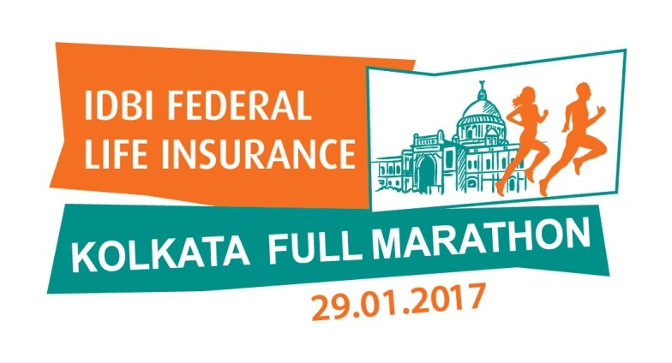

Over 8,000 enthusiastic runners participated in the inaugural IDBI Federal Life Insurance Kolkata Full Marathon 2017
Abul Hossain won the inaugural edition as cricket maestro Sachin Tendulkar cheered on the runners and winners

Kolkata, 29th January 2017: Over 8,000 passionate runners took to the streets of City of Joy today, participating in the inaugural edition of the IDBI Federal Life Insurance Kolkata Full Marathon. Taking the starting line at 5.00am, Full Marathoners (42k) set off along the awe-inspiring route, soaking in the delightful old world colonial charm of the city’s architecture . The Half Marathon (21K) run flagged off at 6:30 am, 10K flagged off at 7:30am, while the crowd favourite, the Apollo Gleneagles 5K Touching Lives Run at 9am.

Sachin Tendulkar was on hand at the Red Road flagging off all four races, animatedly cheering on the enthusiastic runners on a chilly winter morning. The excitement was clearly palpable with Sachin’s presence. Runners waited to take selfies, shake hands with the cricket icon before proceeding for their run.

Sachin Tendulkar, Face of the IDBI Federal Life Insurance Kolkata Full Marathon said, “It was a fantastic event. I am really happy to see so many participants who braved the chilly weather and made it for the marathon. Congratulations to the runners and the winners for showing this spirit of dedication and commitment towards health and fitness. I hope to see many more individuals next year for the marathon."

This is a massive day for Kolkata. We saw a large number of women participants as well. It is a great initiative by IDBI Federal Life Insurance to promote something which will have a positive impact on the common man as far as health and lifestyle is concerned. The participants here today are our heroes, to be able to do what they did requires a lot of discipline, dedication, planning and execution. I am looking forward to the vibrancy in the Delhi marathon coming up next month, Tendulkar added.

Abul Hossain was the first across the finish line, winning the inaugural Kolkata Full Marathon (Male) title with a timing of 2:34:02 where as Biswanath was behind him and finished his race at 2:39:16 and Paritosh Roy came in third with a timing of 2:52:48. In the Half Marathon category, Subhankar Ghosh won the title easily finishing at 1:09:07 and was followed by Jomsing Star Ramsiej and Uttam Bhujel who finished their races at 1:11:03 & 1:13:23 respectively. In Half Marathon Female category, Mangali Tamang finished with a winning time of 1:31:13 followed by Kyntimon Marwein who finished 2nd with timing of 1:33:04 and Dateibankynman Marwein with a time of 1:35:48.

On completion of the Full Marathon and the 21K and 10K run, hundreds were seen wearing a ‘finishers’ medal, proud to have been a part of the inaugural event.

List of winners across categories is as given below:

Male - Full Marathon (42K) – Abul Hossain won the title (2:34:02), Biswanath was the runner-up (2:39:16) and Paritosh Roay came in third (2:52:48)

Male – Half Marathon (21K) - Subhankar Ghosh won the title (1:09:07), Jomsing Star Ramsiej was the runner-up (1:11:03) and Uttam Bhujel came in third (1:13:23)
Female – Half Marathon (21K) - Mangali Tamang won the title (1:31:13), Kyntimon Marwein was the runner-up (1:33:04) and Dateibankynman Marwein came in (1:35:48)

Male – Timed 10K – Pramod Kumar won the title (32.38), Shynsharlang Wahlang was the runner-up (32:39) and Manas Das came in third (34:23)

Female – Timed 10K – Puja Mandal (38:59), Phyrnai Kyndait was the runner-up (44:42) and Dakahi Kyndait (44:44)

For media queries, please contact:
Hiral Jani Vasani: +91 9820039681, hiral.jani@idbifederal.com

For Concept PR
Ralph Payne: 9830021266, Ralph@conceptpr.com
Santosh Barodia: +91 9820509642, Santosh@conceptpr.com

