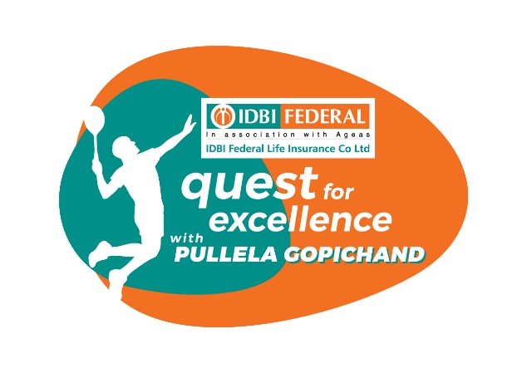

IDBI Federal Life Insurance & Pullela Gopichand announce launch of ‘Quest for Excellence’ programme

Launched with an aim to create World Class Players for Medal Glory

MUMBAI, 22nd December 2016: Private life insurer, IDBI Federal Life Insurance, today announced yet another grassroots sports development initiative – IDBI Federal’s association with Pullela Gopichand to launch the ‘Quest for Excellence’ programme.

The initiative will support country’s vision of creating world-class badminton players to represent India at international tournaments and bring back laurels for the country, including the 2020 Olympics in Tokyo, Japan.

The silver medal by PV Sindhu at Rio Olympics 2016 has propelled the game to its much-deserved eminence in India and one cannot undermine the role Pullela Gopichand has played over the years in developing world-class players for India.

Speaking at the launch announcement of ‘Quest for Excellence’, Vighnesh Shahane, CEO, IDBI Federal Life Insurance said, “By bagging silver in Badminton at Olympics, India has clearly proved its mettle to take this sport to newer heights. At IDBI Federal Life Insurance we wish continue this momentum and support talented players in their endeavour to achieve bigger dreams. An association with Gopichand Badminton Academy strongly reflects our commitment to this game and grassroots sports development in India.”

He adds, ‘’ Gopi needs no introduction; he is a star in his own right and has helped helm some of the biggest names in the country. We are proud to tie-up with him to create a bright future for badminton in the country.”

Pullela Gopichand, Programme Head, Quest for Excellence, said, “In India, Badminton doesn’t get the kind of support that some other sports get. ‘Quest for Excellence’ is great step taken by IDBI Federal Life Insurance in extending its support to train quality badminton players. It is an opportune time for IDBI Federal Life Insurance and our academy to come together and we are excited to push initiatives to promote badminton and hope to inspire a generation of medal-winners.”

About IDBI Federal Life Insurance
IDBI Federal Life Insurance is one of India’s growing life insurance companies and offers a diverse range of wealth management, protection and retirement solutions to individual and corporate customers.
IDBI Federal Life Insurance Co Ltd is a joint-venture of IDBI Bank, India’s premier development and commercial bank, Federal Bank, one of India’s leading private sector banks and Ageas, a multinational insurance giant based out of Europe.
Having commenced operations in 2008, IDBI Federal was able to achieve breakeven within just 5 years; the Company’s passion for innovation and growth helped it achieve this feat.
Through a nationwide network of 2, 964 branches of IDBI Bank and Federal Bank, and a sizeable network of advisors and partners, IDBI Federal Life Insurance has achieved presence across the length and breadth of the country. As on March 31, 2015, the company has issued nearly 7.88 lakh policies with a sum assured of over Rs. 41,856 crore. IDBI Federal Life Insurance has total assets under management of 4,087 crore and a robust capital base of over 800 crores, as on March 31, 2015.
To know more, visit www.idbifederal.com.
About the sponsors of IDBI Federal Life Insurance Co Ltd
IDBI Bank Ltd. continues to be, since its inception, India’s premier industrial development bank. It came into being as on July 01, 1964 to support India’s industrial backbone. Today, it is amongst India’s foremost commercial banks, with a wide range of innovative products and services, serving retail and corporate customers in all corners of the country from 1389 branches and 2301 ATMs. The Bank offers its customers an extensive range of diversified services including project finance, term lending, working capital facilities, lease finance, venture capital, loan syndication, corporate advisory services and legal and technical advisory services to its corporate clients as well as mortgages and personal loans to its retail clients. As part of its development activities, IDBI Bank has been instrumental in sponsoring the development of key institutions involved in India’s financial sector – National Stock Exchange of India Limited (NSE) and National Securities Depository Ltd, SHCIL (Stock Holding Corporation of India Ltd), CARE (Credit Analysis and Research Ltd).
To know more, visit www.idbibank.com.
Federal Bank is one of India’s leading private sector banks, with a dominant presence in the state of Kerala. It has a strong network of over 1,142 branches and 1,312 ATMs spread across India. The bank provides over four million retail customers with a wide variety of financial products. Federal Bank is one of the first large Indian banks to have an entirely automated and interconnected branch network. In addition to interconnected branches and ATMs, the Bank has a wide range of services like Internet Banking, Mobile Banking, Tele Banking, Any Where Banking, debit cards, online bill payment and call centre facilities to offer round the clock banking convenience to its customers. The Bank has been a pioneer in providing innovative technological solutions to its customers and the Bank has won several awards and recommendations.
To know more, visit www.federalbank.co.in.
Ageas is an international insurance group with a heritage spanning 190 years. Ranked among the top 20 insurance companies in Europe, Ageas has chosen to concentrate its business activities in Europe and Asia, which together make up the largest share of the global insurance market. These are grouped around four segments: Belgium, United Kingdom, Continental Europe and Asia and served through a combination of wholly owned subsidiaries and partnerships with strong financial institutions and key distributors around the world. Ageas operates successful partnerships in Belgium, the UK, Luxembourg, Italy, Portugal, Turkey, China, Malaysia, India and Thailand and has subsidiaries in France, Hong Kong and the UK. Ageas is the market leader in Belgium for individual life and employee benefits, as well as a leading non-life player through AG Insurance. In the UK, Ageas is the second largest Motor insurer and has a strong presence in the growing over 50's market. Ageas employs more than 13,000 people in the consolidated entities and over 30,000 in the non-consolidated partnerships, and has annual inflows of more than EUR 23 billion.
To know more, visit www.ageas.com.
For media queries, please contact:
Hiral Jani Vasani: +91 9820039681, hiral.jani@idbifederal.com

For Concept PR
Santosh Barodia: +91 9820509642, Santosh@conceptpr.com
Mangirish Dhume: + 91 88790 86265, mangirish@conceptpr.com

